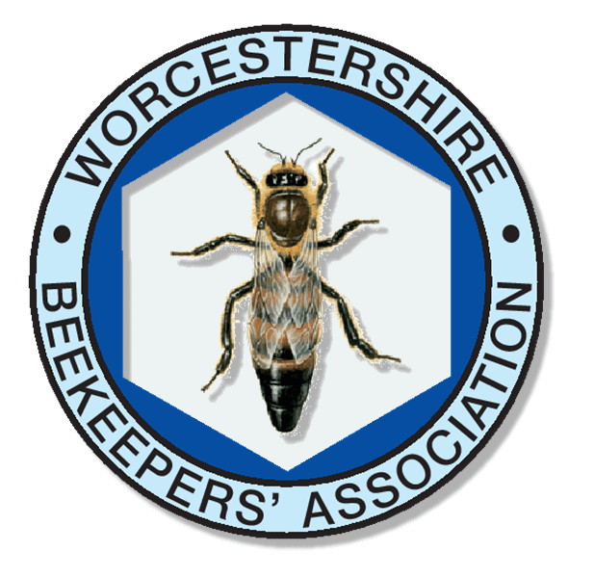
WORCESTERSHIRE BEEKEEPERS' ASSOCIATION
Annual Honey Show 2026
Entry Form
Exhibitor Details
Name
Branch
Email
Telephone
Entry Details
For each class you wish to enter write ‘1’ in the ‘Entries’ column. If you wish to make more than one entry in a class write the number of entries you wish to make in the ‘Entries’ column
Class | Entries | Office  Use |  | Class | Entries | Office  Use
- Light Honey |  |  |  | - Medium / Dark Honey
- Soft / Gran Honey |  |  |  | - Heather Honey
- Honeycomb |  |  |  | - Shallow Frame
- Cut Comb |  |  |  | - Beeswax
- Dry Mead |  |  |  | - Sweet Mead
- Honey Cake |  |  |  | - Beekeeping Products
- Educational Exhibit |  |  |  | - Candles
- Jars ‘For Sale’ |  |  |  | - Gift Honey Clear
- Gift Honey Set / Gran |  |  |  | - Novice – Honey
- Novice – Other |  |  |  | - Photograph

Please send your completed Entry Form to the Show Secretary, John Dowden
By email to john@dowdens.co.uk or post to Upper Mill, Mill Lane, Colwall, Malvern WR13 6HD

